Union Bible Institute
Prospectus
2026

UNION BIBLE INSTITUTE NPC
45 Dennis Shepstone Drive
P.O. Box 50
Hilton
3245

Phone: +27 33 343 4547
Cell: +27 82 447 7877
E-mail: admin@ubi.ac.za
Website: www.ubi.ac.za

UBI is registered with the DHET until 31st December 2026 as a Private Higher
Education Institution under the Higher Education Act of 1997.

Registration No: 2010/HE08/001

TABLE OF CONTENTS

Message from the Principal ................................................. About UBI ....................................................................... Registration and Accreditation ............................................. Medium and Mode of Instruction ......................................... Mission and Values ............................................................ Statement of Faith ............................................................. Educational Philosophy .......................................................
Faculty and Staff ................................................................
4
4
5
5
6-7
8
8
9-13
Financial Information ......................................................... 14-15
College Calendar ............................................................... 15
Programmes of Study ......................................................... 16-17
Admission Requirements .................................................... 18-19
Academic Policies ............................................................. 19-22
Academic Modules ............................................................ 23-32
Fieldwork Modules ............................................................ 33
International Stud..e.n..t.s.......................................................... 33

Accommodation
Computer Training
............................................................ 34
....................................................... 34

Publishing and Media Departments ....................................... 34

Student Life
.................................................................... 34-35

School Rules, Health and Wellness, Disability Policy................ 36-43
Request for Application ...................................................... 43

A MESSAGE FROM THE PRINCIPAL
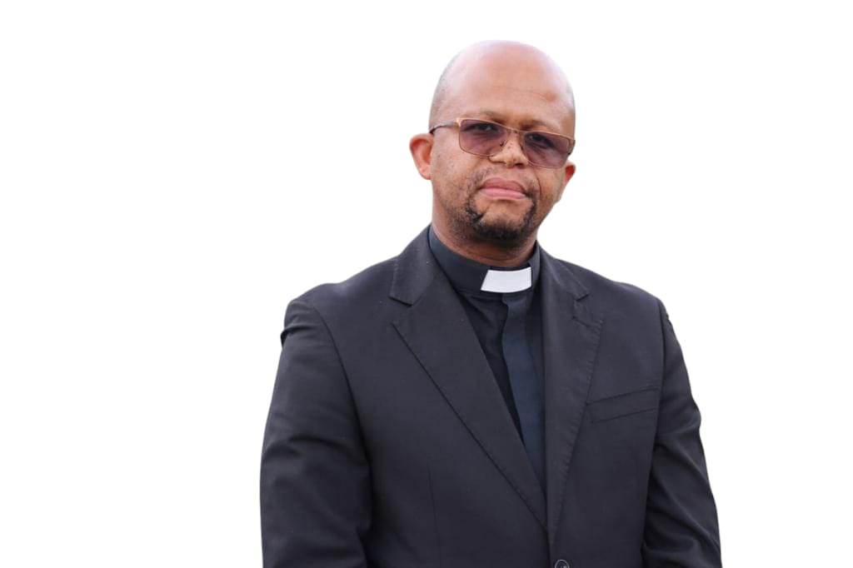

Rev. X.A. Nkosi

As the UBI family, we are truly grateful to God Almighty for all that He continues to give to this institution. UBI has stood the test of time and continues to be used by God in our current generation.

The challenge we have as a school and as a nation is to have men and women who are willing to be used of our Lord Jesus Christ to fearlessly declare the good news of the cross. The mandate of the church has certainly not changed today from what it was yesterday. As we march on, let us not lose focus of our main calling– the making and developing of Christ-like servant leaders who are committed to Christ and His Great Commission. We ought to remind ourselves that commitment to Christ will always come at a price.

Perhaps as we look ahead, we should remain conscious of the Lord’s question of concern which He asked before His departure when He said: “...when the Son of Man comes, will He find faith on earth?” (Luke 18:8).

ABOUT UBI

Since 1941, God has used Union Bible Institute to teach His Word and assist in the development of Christian leaders. UBI remains committed to the unchanging message of the Bible and the preaching of its truth. At the same time, we recognize that the application of the message and the methods we use must meet the need of the times in which we live. UBI is directed by an independent Board/Council representing various Christian denominations and mission societies.

REGISTRATION AND ACCREDITATION

UBI is registered with the Department of Higher Education and Training as a private higher education institution, No.2010/HE08/001, until 31
December 2026. The Bachelor of Theology, Diploma in Theology, and Higher Certificate in Theology programmes are all accredited by the Council on Higher Education. Union Bible Institute NPC (RF) is a Section 21 company, registration number 2004/024020/08.

DIRECTORS

Chairman Dr M. G. Mnisi
Principal Rev. X.A. Nkosi
Secretary Mr.D.Magudulela
Member Rev. P Zondi
Member Rev M Tessendorf
Member Dr M. Shezi
Member Rev.V.M.Thabethe

SENIOR MANAGEMENT

Chairman Rev. X.A.Nkosi
Secretary Mr. E. Binion
Member Ms. R.Dhanorjeeth
SAC Rev.T.N. Mndzebele

MEDIUM AND MODE OF INSTRUCTION

The medium of instruction is English and isiZulu in both the Higher Certificate in Theology and Diploma in Theology, and English in the Bachelor of Theology. The mode of instruction is contact. The Higher Certificate in Theology is also available in distance mode.
MISSION AND VALUES

Union Bible Institute's purpose is to develop Christ-like servant- leaders who are committed to Christ and His Great Commission.

This is accomplished in the following ways:

The Word of God

– By thoroughly grounding prospective Christian workers in the Word of God so that they will be able to understand its basic content and apply its principles to their lives and ministries.

Spiritual Transformation

– By prayerfully depending on God to use us to continue and accelerate the process of transformation that He has already begun in our students

– By guiding the students, through teaching and mentoring, in the development of their character, that they may become more like Christ.

Academic and Ministry Excellence

– By providing both theoretical and practical training in leadership and ministry skills, while modelling the humble attitude of a leader as one who serves.

Worship of Christ

– By exalting Christ through music, prayer, testimony, and every aspect of the life and the curriculum of the school, and through challenging our students to commit themselves wholeheartedly to Him.

Missional Focus

– By exposing students to the need of worldwide evangelization and involving them where possible in cross cultural ministry, yet seeking also to equip them for ministry in their own culture.

In our purpose of seeking to develop Christ-like servant-leaders who are committed to Christ and His Great Commission we shall seek to live out and uphold the following values:

Grace and Truth

While firmly founded on the truth found in the Scriptures, we want to relate to others graciously, extending to them the grace that we have received in Christ.

Individuality and Community

While we value each individual’s gifts, we value being able to live together and work together as a team with gifts that complement one another. We are happy to be part of a multicultural interdenominational community.

Growth and Stability

We appreciate that UBI is continually improving its facilities and programmes and that staff members and students continue to grow spiritually and academically. Though we value growth and change, we appreciate the heritage of the school and its traditions.

Excellence and Affordability

We want to serve churches and communities by providing excellent
preparation for ministry but always in keeping with what is affordable.

IsiZulu and English

UBI’s niche is providing ministry training and publications in the isiZulu language while at the same time providing training to English speakers.

STATEMENT OF FAITH

The curriculum shall be based on the following fundamental truths: the Trinity, the divine inspiration and authority of the scriptures, the deity of our Lord Jesus Christ, including His virgin birth, the efficacy of His death on the cross, His bodily resurrection and personal return, the personality of the Holy Spirit, the fall of man and his lost estate by nature, justification by faith, and the personality of Satan.

EDUCATIONAL PHILOSOPHY

Biblical: In order to give students a biblical basis for their lives and ministry, they are exposed to all 66 books of the Bible.

Evangelical: UBI lecturers come from different denominations but are all committed to the inspiration and authority of Scripture and to the doctrine of salvation by faith in Jesus Christ. Students are exposed to guest lecturers from a variety of evangelical churches.

Practical: UBI lecturers aim to provide continual devotional and practical application of Scripture in and outside the class. Students are specifically trained in ministries such as preaching, evangelism, children’s ministry, and hospital visitation.

UBI ADMINISTRATION TEAM

Rev. Xolani A. Nkosi (Principal)
Xolani A. Nkosi is a UBI alumnus who received a B.Th. Honours from International College of Bible and Mission and a M.Th. from Baptist Theological College. He has recently completed another M.Th. from the University of Pretoria. He joined UBI staff in July 2013. Previously, he was in urban missions in Tshwane and was involved in advocacy work and programme management. He also serves as a pastor in his church.

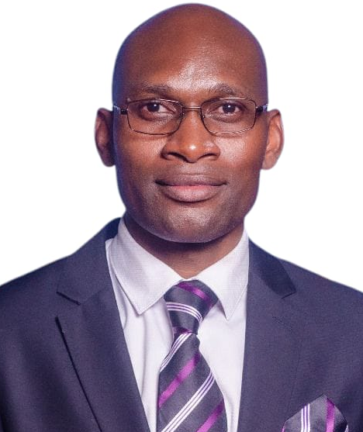
Thakazelelani Mhlanga (Office Administrator)

Thakazelelani Mhlanga graduated from the South African Theological Seminary with a Bachelor of Theology Degree in 2020, and graduated with a Bachelor of Theology (Honours) from South African Theological Seminary in 2022. Currently he is pursuing a Master of Theology at the University of KwaZulu Natal, and a Bachelor of Theology (Honours) in Christian Counselling at the South African Theological Seminary. He is an ordained pastor of The Apostolic Faith Mission of South Africa.


Mr. Keegan Noble (Registrar)
Keegan Noble graduated from UBI and has a Bachelor of Theology (Honours equivalent) from the Baptist Theological College of Southern Africa (2014) and a Master of Theology from South African Theological Seminary. In addition to lecturing, he has served as registrar since July 2014.


Ms. Reshma Dhanorjeeth (Financial Accountant)
Reshma Dhanorjeeth is a graduate of Varsity College with a diploma in Management and Finance. She obtained her Bachelor of Theology (Honours) from the South African Theological Seminary. She joined UBI in June of 2012.


Sindile Moyo (Librarian)
Sindile Moyo joined the UBI staff in 2020. She graduated with a diploma in Theology from Union Bible Institute in 2014.

UBI FACULTY

The faculty is divided into three departments: Biblical Studies, Systematic Theology, and Practical Theology.


Eric Binion (Academic Dean, Lecturer)

Eric Binion was involved in teaching and church planting in Swaziland and Eastern Cape before coming to UBI in 1993. He has a B.A. from Wheaton College, an M.A. from the University of Texas and a Th.M. from Dallas Theological Seminary. He teaches Biblical Studies modules.

DEPARTMENT OF BIBLICAL STUDIES


Simiso Moyo (HOD, Lecturer)

Simiso Moyo graduated from UBI in 2014 and has a B.Th. (Honours equivalent) from Baptist Theological College and a Master of Theology from the University of KwaZulu Natal. He serves as an assistant pastor at his church.

DEPARTMENT OF SYSTEMATIC THEOLOGY
Mr. Keegan Noble (HOD, Lecturer)
He graduated from UBI and has a Bachelor of Theology (Honours equivalent) from the Baptist Theological College of Southern Africa (2014) and a Master of Theology from South African Theological Seminary. In addition to lecturing, he has served as registrar since July 2014

DEPARTMENT OF PRACTICAL THEOLOGY
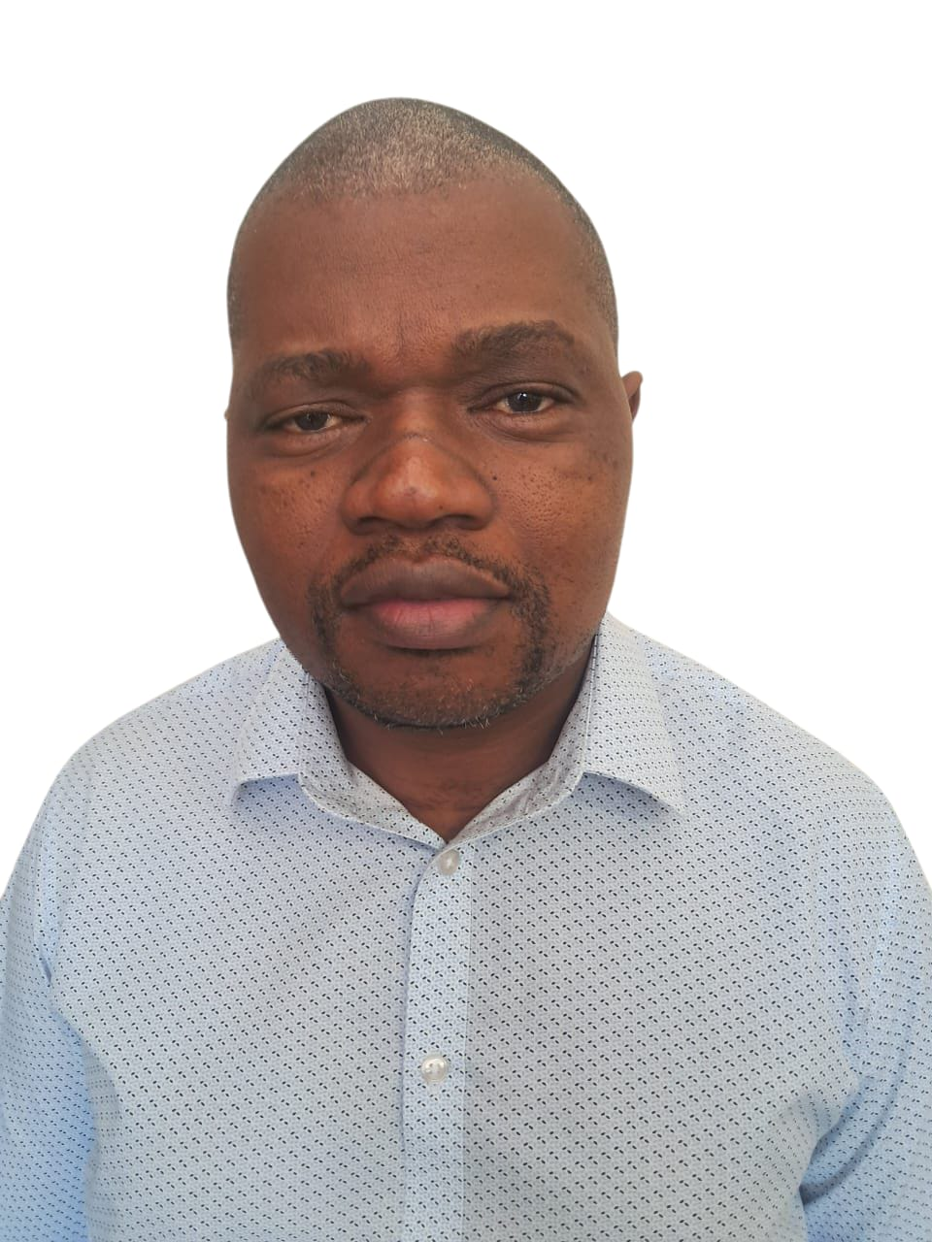
Thulani Mndzebele (HOD, Lecturer)

Thulani Mndzebele graduated with a Bachelor of Education (Intermediate and Senior Phase) at UNISA. He then proceeded to a Bachelor of Theology Honours degree at Baptist Theological College (BTC). He currently holds a Masters in Theology degree from BTC.

LECTURERS

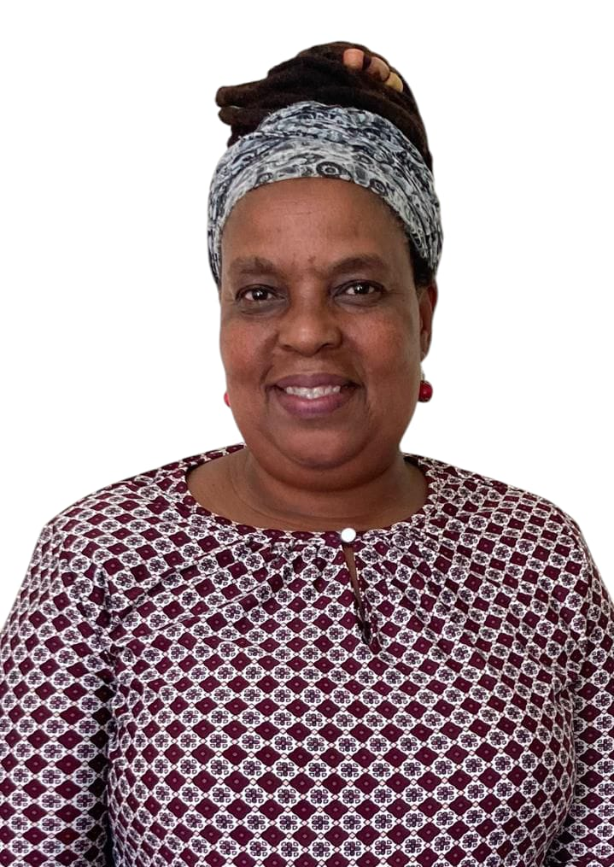
Bongi Dumisa (Lecturer)

Bongi Dumisa graduated from UBI in 1994 and has been serving as a missionary with YWAM since 1995. She obtained her Bachelor of Theology (Honours equivalent) from Baptist Theological College in 2014. She has assisted with UBI Publishing and part-time lecturing since 2012 and became part of the full-time lecturing staff in 2021.


Ntokozo Happiness Ngcongo (Lecturer, Distance Learning Coordinator)

Ntokozo Happiness Ngcongo graduated from UBI in 2016 with a Diploma in Theology degree. She then proceeded to the Baptist Theological College where she acquired a Bachelor of Theology degree in 2019. She the graduated with a Master of Theology degree from Baptist Theological College in 2022.

ADJUNCT LECTURERS

Dr. Richard Murray (Lecturer, IT Manager)

Richard Murray served as a missionary in Malawi prior to coming to UBI in 1994. His theological training was at the Baptist Theological College of Southern Africa and he has a Doctor of Ministry degree from Luther Rice Seminary, USA.


Dr. Rose Nyirimana (Lecturer)
Rose Nyirimana is a Christian, a mother and a wife. She was born in Rwanda but is living in South Africa. She holds a PhD in Biblical Studies from the University of KwaZulu-Natal. Rose has been a lecturer at UKZN, St Joseph Theological Institute (Cedara), Evangelical Seminary of Southern Africa (ESSA) and Seth Mokitimi Methodist Seminary (SMMS). Her area of specialization is New Testament and Hellenistic Greek.
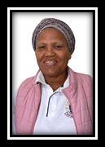
Nokuthula Tshazi (Lecturer)
Nokuthula Tshazi joined the UBI staff in 2017 after completing her Diploma in Theology at UBI in 2015 and her Bachelor of Theology (Honours equivalent) from Baptist Theological College in 2016.

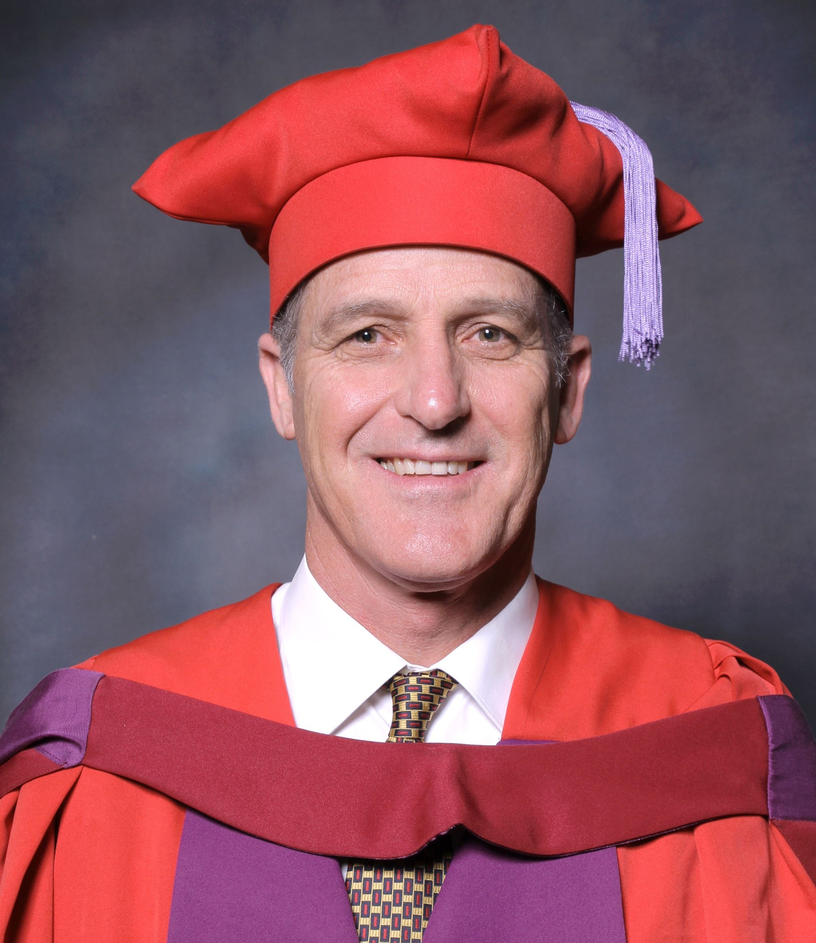
Dr. Craig Linden (Lecturer)
Dr. Craig Linden joined the UBI staff in 2026 as an adjunct lecturer. He holds the following academic qualifications: Licentiate in Theology from the Bible Institute of SA, (1985), Licentiate in Theology from the Baptist Theological College (Cum Laude) (1987). MA (Practical Theology) University of Pretoria (2011), PhD (Practical Theology) University of Pretoria (2015). He has done pastoral work in four local churches from 1998 to 2025.

PROJECTS AND FUNDRAISING

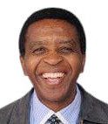
Dr George Mnisi (Project Manager)

Dr George Mnisi graduated from the University of Fort Hare with a Bachelor of Science degree. He went on to earn the Bachelor of Theology degree from the University of Zululand, the Licentiate in Theology (Honours) from Baptist Theological College and Masters and Doctorate degrees from Rand Afrikaans University. For ten years he pastored two churches in the Pretoria area and lectured part-time at Dorothea Bible School before coming to UBI in 2008 where he served as Principal until 2023. He also pastors a church in Pietermaritzburg on a part-time basis.

UBI STAFF

Susan Binion (UBI Publishing manager, part- time lecturer)

Susan Binion assists with the music programme, manages UBI Publishing, and lectures in the Practical Theology Department on a part-time basis. She has a Bachelor of Science degree in Education as well as a Bachelor of Arts degree from the University of Texas.


Emmanuel Mwanza (Maintenance Manager)

Emmanuel Mwanza trained at KZN Missionary and Bible College, Pietermaritzburg. In addition to assisting with maintenance, he is an assistant pastor at Oasis of Worship. He came to UBI in 2015.

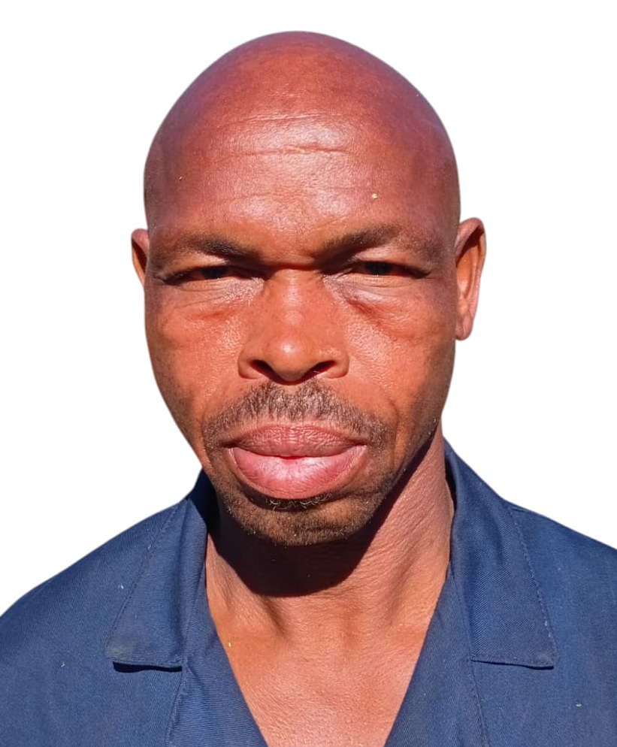
Jeff Khumalo (Maintenance assistant)

Jeffrey Khumalo has been assisting with maintenance at UBI since 2003.

FINANCIAL INFORMATION

All fees are payable in advance, at the beginning of each term. Please note: when depositing fees, please ensure the name of the student is on the deposit slip in order for the right student’s account to be credited.

2026 SCHOOL FEES:

Fees for Higher Certificate in Theology and Diploma in Theology

On Campus for the year: R42,488.00
Off Campus for the year: R31,256.00

Fees for Bachelor of Theology

On Campus for the year: R44 896.00
Off Campus for the year: R33 664.00

Audit Module = R544.50
Credit Module (Higher Certificate/Diploma) = R1953.50
Credit Module (B.Th.) = 2104.00

Married Student House Rent = R27 225.00 for ten months (R2722.50 per month)

Please note that on-campus fees include accommodation but no food. Students cook for themselves in the UBI kitchen.

Registration Fee is R1463.00 – One-time, Non-refundable

If you pay your application fee by direct deposit, please post or fax us a copy of the deposit slip (and please put the name of the student who it is for on the slip) at 086 443 5077. All monies must be deposited directly into UBI's account or delivered in person. Please do not send any money by post. UBI account and contact details are on the last page.

FINANCIAL AID

Please note that UBI has only a small Bursary Fund. All students who have been admitted must raise their own financial support to pay for their studies. The school fees for each term are payable before or on the first day of each term. Students may apply for a Work Scholarship which involves weekly hours of work on campus and provides partial funding for tuition and expenses.

COLLEGE CALENDAR FOR 2026

Orientation 22– 23 January
Term 1 26 January to 27 March
Term 2 13 April to 12 June
Term 3 06 July to 04 September
Term 4 21 September to 23 November
Graduation 28 November

Please note: All students must attend Graduation.

PROGRAMMES OF STUDY

Higher Certificate in Theology (1 year, 120 credits, NQF Level 5)

The purpose of the Higher Certificate programme is to train lay people in the Bible and theology and to help them determine whether they are called to full-time servant-leadership in their church or other ministry. Students must obtain 120 credits by passing 15 modules to graduate, including one fieldwork module. This can be done in one year of full- time study or two or more years of part-time study. The Higher Certificate programme is offered in both English and isiZulu.

Compulsory modules include four Biblical Studies modules (Hermeneutics, Pentateuch, Synoptic Gospels, Acts), four Systematic Theology modules (Bibliology, Christology, Pneumatology, and Soteriology), and four Practical Theology modules (Children’s Ministry, Homiletics 1, Devotional Theology, and Children’s Ministry fieldwork). Three electives may be chosen to complete the fifteen total required. Module descriptions are found elsewhere in this prospectus. In addition, students are given programme guides which show the required and elective modules for each programme.

UBI offers evening classes four nights per week (Monday to Thursday) from 6 PM to 8 PM. Students may take either one or two modules per term. Evening students can therefore complete the Higher Certificate in two years by taking two modules per term. In addition, UBI often offers a two- week Winter School in July in which students can take one module.

Graduates may apply half of their credits toward the Diploma in Theology or Bachelor of Theology, should they apply and be accepted to continue their studies at UBI.

Diploma in Theology (3 years, 360 credits, NQF Level 6)

The Diploma programme aims to give students the knowledge, skills, and attitudes to equip them to lead churches and other organizations with

excellence. Students must obtain 360 credits by passing 37 compulsory
8-credit academic modules (296 credits), compulsory and elective fieldwork modules (24 credits), and five electives (40 credits) in order to graduate. The Diploma programme is offered in isiZulu, and students may also choose to take most of the modules in English.

The compulsory academic modules are BBS01, BOT01-07, BNT01-09, GSR01, GSE02, GSC02, PPT01-02, PPT04, PPT07-09, PPT11-12, TST01-
06, TCC01, and TCH02. The compulsory fieldwork modules are PFW00, PFW01, and PFW04. The module descriptions are found elsewhere in this prospectus. Students are given programme guides, which show the required and elective modules for each programme.

Bachelor of Theology (3 years, 360 credits, NQF Level 7)

The Bachelor of Theology degree programme aims to give students the knowledge, skills, and attitudes that enable them to lead churches and other organizations with excellence. This programme also prepares students for further theological study. It emphasizes research and the use of the original biblical languages, Greek and Hebrew.

Students must obtain 360 credits to graduate. They must pass 38 compulsory 8-credit academic modules (304 credits), compulsory and elective fieldwork modules (24 credits), and four electives (32 credits) in order to graduate. The BTh programme is offered in English.

The compulsory academic modules are BBS01, BBG01-03, BBG
05-11, BBH01, BBH03-05, BOT01-03, BOT06, BNT01-02, GSR02, GSE02, PCE01, PPT01-02, PPT04, PPT09, PPT11, TST01-06, TCC01, TCH01, and TCH04. The compulsory fieldwork modules are PFW00, PFW01, and PFW04. The module descriptions are found elsewhere in this prospectus. Students are given programme guides which show the required and elective modules for each programme.

Graduates of the Bachelor of Theology programme qualify for admission to a Bachelor Honours degree programme.

ADMISSION REQUIREMENTS

Higher Certificate in Theology

Learners must have a National Senior Certificate and be recommended by their church leadership. Students who do not have a National Senior Certificate or Grade 12 Certificate but who are 23 years or older and have completed Grade 10 or who are 40 years of age or older may be admitted on the basis of Recognition of Prior Learning (RPL).

Diploma in Theology

Learners must have a National Senior Certificate with a minimum of
40% in four recognized subjects and be recommended by their church leadership. Students who do not have these qualifications but have received the Higher Certificate in Theology may also be admitted. Students who are 23 years of age or older and have completed Grade
10 or who are 40 years of age or older may be admitted on the basis of
Recognition of Prior Learning (RPL).

Bachelor of Theology

Learners must have a National Senior certificate with a minimum of
50% in four recognized subjects and be recommended by their church leadership. Students who have completed the UBI Higher Certificate in Theology with an average of 65 or above may also be admitted. Students who are 23 years of age or older and have completed Grade 10 or who are 40 years of age or older may be admitted based on Recognition of Prior Learning (RPL).

Recognition of Prior Learning and Transfer of Credits

No more than ten percent of a cohort of students in any programme will be admitted through an RPL process. Students should contact the Registrar if they wish to be admitted based on RPL.

The Union Bible Institute will recognize prior learning from other institutions of higher education under the following conditions:

1. The student presents to the Registrar an official transcript from
the other institution.

2. The Academic Committee is satisfied that the modules passed correspond closely to modules offered by UBI both in content and in notional hours.

3. The modules constitute half or less of the total needed for the
qualification.
ACADEMIC POLICIES
Modules and Terms: UBI has four terms of nine weeks each. Each term students normally take four academic modules. Each module is 8 credits which represents 80 notional hours (80 hours of work inside and outside of the classroom). Each module includes four or five 50-minute classes per week for eight weeks followed by an exam week. Students normally also take one fieldwork module each term.
Programme selection: Students admitted to UBI will be placed in a programme according to their choice and their qualifications. Students will be informed of their options in their acceptance letter and in their initial interview during Orientation. They will then meet with the Registrar during Orientation or the first week of classes and sign a Confirmation of Programme form stating which programme they are entering.

Streams of study: Students must choose either the English or isiZulu stream and may not register for modules in the other stream. Students may make a written request to the Academic Dean or Registrar if there are special circumstances that need to be considered. Students may switch streams at the beginning of any term but not after the eighth day of the term.
Programme guides: Each UBI programme has a number of mandatory modules which students must pass in order to graduate. Each student will receive a programme guide and a list of mandatory modules for that programme. Each programme also has a certain number of elective modules.
Marking scale: The pass mark is 50 percent. Marks in the 50s represent below average work, marks in the 60s represent average work, marks in the 70s represent above average work, and marks in the 80s and above represent excellent work. Assignments that are submitted after the due date receive a penalty (10 percent deducted per day late). Students who miss tests or quizzes may write them later as supplementaries for a maximum of 50%.
Continuous assessment: The student’s work is assessed on an ongoing basis throughout the term. All work done and assessed by the lecturer counts towards the student’s final mark. Class tests, assignments, and group projects form part of the assessment tools during the term.
Passing mark and sub-minima: Students must have an overall mark of 50% or higher to pass a module. In addition, students must have an average of 40% or higher on the term work in order to qualify to write the exam, and students must score 40% or higher on the exam.
If a student fails a module due to not achieving the sub-minimum for the exam yet has an overall mark of 50% or higher, he or she will receive a mark of 45 for the module and will be given the opportunity to write a supplementary exam. If a student fails a module due to not achieving the sub-minimum for the term work, his or her term mark will become the final mark.
Examinations: Final examinations are given during the last week of the term and take two hours to write. The final exam counts between 25% and 40% of the final mark. Final examinations are comprehensive--that is, the student is tested on the most important material of the entire module. Students must have an average of 40 percent or higher on the term work in order to qualify to write the exam. Students must also score at least 40 percent on the final exam to pass the module. Students may see their marked exam papers, but both the question papers and scripts are kept by UBI.
Cell phones, books, and notes are not allowed in the examination room. Students may not leave the examination room and come back in again.
Supplementary exams: A final mark of 45% to 49% qualifies a student to write a supplementary exam. Students who achieve 50% or higher on the supplementary exam will receive a final mark of 50%. A fee must be paid in order to write a supplementary.
Re-marking of assignments or exams: If a student feels his work has been incorrectly marked he or she should discuss the matter with the lecturer. If the problem is not resolved, the student may take the matter to the Academic Committee. If the work has to be re-marked by a second internal assessor or an external assessor, the student will be required to pay a fee.
Class attendance: UBI’s purpose is to develop Christ-like servant leaders who are committed to Christ and His Great Commission. The classroom lectures and discussions are an important part of this training. Students are therefore required to attend all classes. Students are allowed to miss class for medical reasons, funerals, or other emergencies. If more than four hours of a module are missed, the student’s final mark will be reduced by five percent for each class period missed over four. If more than eight class hours of a module are missed, students will not receive credit for the module apart from special permission from the Principal. Evening classes meet for two hours, so if a student misses a whole evening he or she would have missed two class hours. Students who do not complete modules due to absenteeism will receive no tuition refund and no mark for the module; the transcript will simply say “Withdrew.”
Students who miss classes must take responsibility to contact the lecturer and make arrangements to make up any assignments or tests missed and to get any notes that were handed out. Students who know they are going to be absent should contact lecturers ahead of time.
Books and notes: Lecturers try to get books which are affordable, relevant, and understandable. If such books are not available, lecturers provide students with photocopied notes. Students wishing to buy books should see if they are available at UBI, or consult the Bible Centre in town or order them online through the UBI bookkeeper, with advance payment.
Registration for extra modules: Students normally take four modules per term. Students may register for five modules in a term if they present a written request to the Academic Dean or Registrar and receive counsel.
- Students will not be given credit for a fifth module taken without approval or for which they have not registered.
- Students must register for a module in order to receive credit. Students who bypass this process will not receive credit.
Independent Studies: Independent studies are normally made available to students who registered for a module and attended classes but did not pass the module. Independent studies will not be granted if the student will have another opportunity to take the module before the normal graduation date. Independent studies should be under the guidance of a lecturer who agrees to grant the student private tutorials. The student should fill out a Request for Independent Study form. The student will be charged 150% of the normal module tuition fee.
Audit policy: Full-time students or alumni who wish to audit classes may do so at 25% of the audit fee. Other students must pay the full audit fee. Auditors may receive notes and may do the assessments if they so choose.
Withdrawing from a module: Students are not allowed to withdraw from modules except in severe cases of illness or at the discretion of the Academic Committee.
Module evaluations: As in most tertiary institutions, students are asked to evaluate their modules on module evaluation forms given out before writing exams. The evaluations are given to the Head of Department, Academic Dean or Principal and are not seen by the lecturer. The supervisor will summarize the evaluations and give written or oral feedback to the lecturer. The purpose of the evaluations is to help the instructor improve the module for future students. These evaluations are extremely important so students are requested to answer them thoughtfully and honestly.
Plagiarism: Students who plagiarize for the first or second time will be given further instruction concerning plagiarism and will be required to do the assignment again if they wish to receive marks. The plagiarism will be reported to the Academic Dean. Students who plagiarize for the third time (as well as any third-year student) will be given a warning that will be reported to the Academic Dean. They will receive no marks for the assignment and will not be given an opportunity to repeat it. Students who plagiarize for the fourth time (as well as any third-year student who seriously and deliberately plagiarizes, even if it is a first offense) will be reported to the Disciplinary Committee which will take appropriate action. Collusion (using another student’s work) carries the same penalties. Students are not allowed to use the Artificial Intelligence (AI) without the permission of the lecturer. Whenever AI is used, it must be acknowledged.

Graduation: Only students who have completed all the requirements for graduation shall participate in the graduation ceremony. Students may participate in special end-of-year activities and awards with the class in which they entered.
Character development: UBI’s purpose is not only to promote academic achievement but also character and spiritual development. Chapel services and small groups (“Khuthazanani Groups”) are intended to help produce this development. All students are required to attend these. In addition, each student is assigned a mentor from the staff who will be available to advise and encourage the student.
Cum Laude: Students who achieve an overall average of 75% or above will graduate Cum Laude. Those with an overall average of 85% or above will graduate Magna Cum Laude.
Awards: At graduation, awards are given to students based on academic achievement and Christian character. The Principal’s Award is given to a graduating B.Th. student and the Stephen Award is given to a graduating Diploma student or students. The Timothy Award is given to a first-year student or students. The Principal’s Award, Stephen Award and Timothy Award are cash awards. Book Awards are given to certain graduating and first-year students.

ACADEMIC MODULES (8 credits each)

BIBLICAL GREEK

BBG01 BIBLICAL GREEK 1
An introduction to Greek grammar and vocabulary, focusing on noun cases,
present active indicative verbs, prepositions, and adjectives.

BBG02 BIBLICAL GREEK 2
A continuing introduction to Greek grammar and vocabulary, with emphasis
on Greek pronouns and other verb tenses.

BBG03 BIBLICAL GREEK 3
A continuing introduction to Greek grammar and vocabulary, introducing participles and other moods of the verb.

BBG04 GOSPEL OF JOHN IN GREEK
A study of the Gospel of John including its background and authorship, its distinctive themes, and its contribution to New Testament theology, using both the Greek and English texts.

BBG06 ROMANS
A study of Paul’s epistle to the Romans, emphasizing the doctrine of salvation, an understanding of the major theological themes, and the various uses of the genitive case, using both the Greek and English texts.

BBG07 1 CORINTHIANS
A study of 1 Corinthians, using both the Greek and English texts, incorporating the archaeological discoveries related to Corinth.

BBG08 PRISON EPISTLES
A study of Paul’s epistles to the Ephesians, Philippians, Colossians, and Philemon, using both the Greek and English texts.

BBG09 PASTORAL EPISTLES
A study of 1 & 2 Timothy and Titus using both the Greek and English texts.

BBG10 HEBREWS
A study of the epistle to the Hebrews based on the Greek and English texts.

BBG11 GENERAL EPISTLES
A study of the epistles of James, Peter, John, and Jude based on the Greek and English texts.

BIBLICAL HEBREW

BBH01 BIBLICAL HEBREW 1
An introduction to the Hebrew alphabet, grammar, and vocabulary.

BBH02 BIBLICAL HEBREW 2
A further introduction to Hebrew vocabulary and grammar.

BBH 04 OT PROPHETS 2
An overview of Jeremiah, Ezekiel, and Daniel and the Post- Exilic minor prophets, making use of insights from both the English and Hebrew texts.

BBH05 POETIC BOOKS
An introduction to poetry and wisdom literature, with an overview of the books of Job, Psalms, Proverbs, Ecclesiastes, Song of Solomon, and Lamentations, stressing the benefit of the use of Hebrew in study and sermon preparation.

BIBLICAL STUDIES

BBS01 HERMENEUTICS
An introduction to inductive Bible study, Bible study methods (synthetic, analytic, and topical), and general and special principles for interpreting the Bible.

OLD TESTAMENT

BOT01 PENTATEUCH
An introduction to the Pentateuchal problem, to the major themes of the Pentateuch, and to the historical and cultural background of ancient Israel, with an emphasis on the historical narrative sections in the Pentateuch.

BOT02 JOSHUA, JUDGES, UNITED KINGDOM
A study of the history of Joshua through the United Kingdom, emphasizing the purpose and outline of each book, leadership principles from the lives of the biblical characters, and instruction in preparing a biographical sermon.

BOT03 DIVIDED KINGDOM, EXILE, AND RETURN
A study of the history of Israel during the Divided Kingdom, exile, and return, and an overview of the history of the intertestamental period.

BOT04 OT PROPHETS 1
A study of the book of Isaiah and the Pre- Exilic minor prophets, focusing on the conditions of Judah at the time of Isaiah and the political scene internally and externally, as well as the prophecies concerning the Messiah and the future kingdom.

BOT05 O.T PROPHETS 2
A study of the historical narrative sections of Jeremiah, Ezekiel, and
Daniel, and the Post- Exilic minor prophets, with an introduction to their prophecies.

BOT07 POETIC BOOKS
A study of the books of Job, Psalms, Proverbs, Ecclesiastes, Song of Solomon, and Lamentations, focusing on the interpretation and use of poetry and wisdom literature in preaching and worship.

NEW TESTAMENT

BNT01 SYNOPTIC GOSPELS
A historical, literary, and theological study of the gospels of Mark, Matthew, and Luke, examining the unique perspectives of each of these gospels as well as their common themes regarding the life of Christ.

BNT02 ACTS
A study of the book of Acts with overviews of Galatians and 1 and 2 Thessalonians.

BNT03 GOSPEL OF JOHN
A study of the Gospel of John including its background and authorship, its distinctive themes, and its contribution to New Testament theology

BNT04 ROMANS
A study of Paul’s epistle to the Romans, emphasizing the doctrine of salvation, an understanding of the major theological themes, and memorization of key passages.

BNT05 1 CORINTHIANS
A study of 1 Corinthians, focusing on Paul’s teaching concerning the problems troubling the church at Corinth and its relevance and application to the church today.

BNT06 PRISON EPISTLES
An examination and exegesis of Ephesians, Colossians, Philippians, and Philemon, with emphasis on their historical-cultural and social context, structure, and key theological themes.

BNT07 PASTORAL EPISTLES
A study of 1 and 2 Timothy and Titus, with emphasis on the doctrine of the church and the developing of a philosophy of ministry.

BNT08 HEBREWS
A historical, literary, and theological study of the epistle to the Hebrews, including a study of the Old Testament tabernacle and sacrificial system.

BNT09 GENERAL EPISTLES
A historical, literary, and theological study of the epistles of James, II Peter, & I I, II, & III John, and Jude.

GENERAL STUDIES

GSC01 COMPUTER SKILLS 1
A practical course in which students acquire typing and word-processing skills, begin to use Windows-based programmes, and learn to use the internet for research. This is a bridging course to help students gain admission into a UBI programme.

GSC02 COMPUTER SKILLS 2
A practical course which introduces students to a Church Management
System.

GSE01 BASIC ENGLISH
A practical course to help students gain proficiency in English as a second language with a strong emphasis on class participation in speaking, listening, reading, and writing. This is a bridging course and its credits cannot be applied toward a UBI qualification.

GSE02 ENGLISH COMPOSITION
This course is designed to sharpen and improve English writing and critical thinking with a goal that the student is able to formulate clarity of expression verbally as well as orally.

GSR01 LIBRARY USE AND STUDY SKILLS
An introduction to the library and its resource to help students know how to use the library, how to do research, how to develop good study habits, and how to write effective essays.

GSR02 RESEARCH METHODOLOGY
This course focuses on analytical and systematical reading, accurate essay writing, individual thinking and creativity, study methods, library use and plagiarism.
PRACTICAL THEOLOGY

PPT01 HOMILETICS 1
An introduction to homiletics, with special attention given to the preparation to the ministry of the preacher and the preparation of an expository sermon, a topical sermon, and sermon outlines.

PPT02 HOMILETICS 2
This course includes the theory and practice of preparing a 25-minute sermon and a 5-minute radio message, as well as practice in evaluating sermons.

PPT04 DEVOTIONAL THEOLOGY
This course examines the meaning of devotion within the context of the Christian faith and explores ways of expressing and evaluating one’s devotion to God.

PPT05 WORSHIP
A biblical and historical survey of music and worship, along with practical principles for setting up or renewing the music and worship ministry in the local church.

PPT06 EVANGELISM
A study of the biblical principles, models, and motivations of evangelism, as well as practical instruction in preparing a personal testimony, explaining the gospel to another individual, dealing with questions, and memorizing key verses.

PPT07 CHURCH PLANTING
A study of the biblical basis and various techniques of starting new churches and of encouraging the growth of existing churches.

PPT08 PASTORAL THEOLOGY
A study of the definition of the term “pastor” and the qualifications, call, role, and responsibilities of a pastor, with particular emphasis on conducting weddings, funerals, baptisms, Lord’s Supper, child dedication and home visitation.

PPT09 COUNSELLING 1
An introduction to various understandings of human personality, and various problem areas, in light of Scripture. The course seeks to equip students to recognize the causes of emotional problems and to apply biblical solutions, as well as to recognize the responsibilities and dangers inherent in the counseling process.

PPT10 COUNSELLING 2
A study designed to equip students to work through their own and other people’s emotional challenges, with emphasis on specific issues such as depression, death, occult issues, HIV/AIDS, abuse, addictions, and trauma.

PPT11 LEADERSHIP 1
A study of servant leadership in the pastoral context, focusing on the skills of planning, leading, organizing, and controlling.

PPT12 LEADERSHIP 2
A study of servant leadership in the pastoral context, focusing on principles of financial freedom and management as well as principles of managing and resolving conflicts.

PPT13 CHURCH IN SOCIETY
A study of the church’s role in society, with particular attention to the issues of racism, sexism, poverty, crime, violence, HIV/AIDS, family disintegration, and urbanization in South Africa today.

PPT14 TOLERANCE AND EMPATHY
A study of the biblical teaching on grace, acceptance, compassion, diversity, and love, with application to political, denominational, cultural, racial, gender, and sexual orientation issues in Africa today.

CHRISTIAN EDUCATION

PCE01 CHILDREN’S MINISTRY
A study of the biblical basis, objectives, and methods of ministry to children with emphasis on teaching children the Word of God, qualities of a teacher, characteristics of children, methods of teaching, and preparation and use of visual aids.

PCE03 TEACHING METHODS
An introduction to the basic principles and methods of teaching. Students gain experience using various methods to teach passages in Philippians or 2 Corinthians.

PCE04 YOUTH MINISTRY
An introduction to adolescent development and leadership principles for youth ministry, as well as of practical issues facing youth, such as submission to authority, peer pressure, addictions, courtship and marriage, self-acceptance, etc. Relevant passages from the book of Proverbs are studied.

PCE05 WOMEN’S MINISTRY
An introduction to the principles and methods of ministry to women in the church.

PCE06 CHRISTIAN HOME
An introduction to the biblical teaching concerning courtship, engagement, marriage, parenting, singleness, family finances, and polygamy, with emphasis on distinguishing between cultural practices that are biblically acceptable and those that are not.

PCE 07 MEN’S MINISTRY
An introduction to the principles and methods of ministry to men in the church.

CROSS-CULTURAL MINISTRY

TCC01 MISSIONS 1
An introduction to the biblical basis of missions and the history of missions.

TCC02 MISSIONS 2
An introduction to modern missions and the structures, strategies, and challenges for missions today.

TCC05 COMPARATIVE RELIGION
An introduction to the major religions of the world as well as the major cults present in South Africa.

CHURCH HISTORY

TCH01 CHURCH HISTORY
A survey of the unfolding history of the Christian church from the New Testament times to present age, emphasizing the early church, the church in the Middle Ages, and the church in the Reformation period. It also includes a survey of the history of Christianity in Africa, emphasizing developments in the Republic of South Africa.

TCH04 CAPSTONE
A module for third-year students in which students synthesize what they have learned for three years and produce a mini-thesis on a topic of their choice.

SYSTEMATIC THEOLOGY

TST01 BIBLIOLOGY
A study of the Bible with emphasis on the nature of Scripture (special revelation, divine inspiration, authority, and inerrancy), the canonicity and transmission of the Old and New Testament books, the translation of the Bible, and an overview of the biblical books.

TST02 CHRISTOLOGY
A study of the teaching of Scripture concerning the Trinity, with emphasis on the Father and the Son, including the names, attributes, and providence of God.

TST03 PNEUMATOLOGY
A study of the teaching of Scripture covering the Holy Spirit, Satan, angels, and demons.

TST04 SOTERIOLOGY
A study of the teaching of Scripture concerning man’s origin and nature, sin, and salvation.

TST05 ESCHATOLOGY
A study of God’s revelation about the future of the church and man with an emphasis on the prophecies of Daniel and Revelation.

TST06 ETHICS 1
An introduction to ethics, based in biblical authority, with special attention given to contemporary issues Christians face in the world today such as capital punishment, civil disobedience, contraceptives, abortion, suicide, euthanasia, homosexuality, and AIDS.

TST07 ETHICS 2
A more in-depth study of selected ethical issues that are affecting life in
Southern Africa today.

FIELDWORK MODULES

PFW00

PFW01

PFW02

PFW03

PFW04

PFW05

PFW06

PFW07

PFW08
CHILDREN’S MINISTRY OBSERVATION CHILDREN’S MINISTRY FIELDWORK YOUTH MINISTRY
LEADERSHIP MENTORING
MINISTRY TRIP MUSIC MINISTRY EVANGELISM HOSPITAL MINISTRY
PRISON MINISTRY
(2 credits) (8 credits) (6 credits) (6 credits) (6 credits) (4 credits) (4 credits) (2 credits)
(6 credits)

INTERNATIONAL STUDENTS

1. Study Permits: An international student must have a South African study permit, which must be applied for in the student’s country of residence, and must be obtained before coming to UBI. Permits may take several weeks to obtain.

2. Payment of Fees: Unless an international student has a South African based sponsor, school fees must be paid for one year in advance. Unused funds will be refundable if the student should be unable to complete his/ her year of study. Fees should be paid through a bank transfer and the deposit slip faxed to UBI.

3. School Breaks: International students will be required to find accommodation off UBI campus during our long school breaks of December-January and June-July. During the short mid-term breaks, students may live in the dorm.
ACCOMMODATION

UBI provides accommodation for men and women students in dormitories. A bed and mattress are provided, but students must bring their own sheets, pillows, pillowslips, towels, blankets and toiletries. Married students who come with their spouses may apply for one of the furnished married student flats. Winters are cold here and summers are rainy. Students should bring an umbrella, warm clothing, clothing suitable for use during manual work, and an electric iron.

COMPUTER TRAINING

UBI provides each student with computer training for use in sermon preparation, church administration, and research. Most written assignments are done on computer in the students' computer room.

PUBLISHING AND MEDIA DEPARTMENTS

UBI publishes nearly 60 different Bible commentaries and devotional books in isiZulu. About 15,000 of these books are sold every year, making UBI one of the largest publishers of isiZulu Christian literature. These books are available through UBI or bookshops. Contact us to receive a book catalogue.

UBI has an extensive selection of preaching and teaching recordings as well as music CDs by various UBI choirs. CDs are available from UBI in isiZulu, isiXhosa, and English. Contact us to receive a media catalogue.

STUDENT LIFE

In addition to coursework, full time students at UBI enjoy many other activities that round out the UBI campus experience.

Devotions and Prayer Services are held midweek and on weekends.

Chapel services are held two mornings per week. Students and staff come together for worship and preaching. Chapel services introduce local, national and international guest speakers.

Sports: Soccer, volleyball, table tennis and netball facilities are available.

Music: Students may serve the school and the broader Christian community through participation in the main UBI choir, the ensemble One Voice, and the marimba band.

Practical ministries include teaching children, hospital visitation, assignments in local churches, ministry trips, and voluntary student-led weekend street evangelism.

Khuthazanani Groups: Each student belongs to a fellowship group that is under the leadership of a staff member. Each group meets at least twice per month for fellowship, prayer and discussion of subjects of interest to the group.

Mentoring: Each student is allocated to a staff member who mentors the student during his or her stay at UBI. Students meet with their mentors at least twice per month for counselling and spiritual nourishment.

Social events: The Student Council plans social events, sporting events, and occasional outings for students. In addition, UBI plans social events to link the day and evening students.

Sisebenza Kanyekanye: Wives of students are encouraged to participate in a prayer partner ministry led by the UBI female staff. Whether they live on campus, nearby or far away, they have a mentor to encourage and pray for them. Occasional programmes are planned for wives as well as for couples. Wives of graduates are invited for a full weeklong programme during the week before Graduation.

SCHOOL RULES

The administration firmly believes that a Christian does not need a set of rules to help him/her live a Christian life. However, it is helpful to have a direction on how we can live in harmony together, doing the same things in an orderly manner without treading on one another’s toes. That is what these rules are meant for.

1. All students must constantly bear in mind that they are at a Bible
School and always act and live as followers of the Lord Jesus Christ.

2. Students must be in class at the normal time of 9 AM at the beginning of first and third terms and at 7:10 AM at the beginning of second and fourth terms.

3. Attendance is compulsory at all lectures, chapel services, study periods and all other activities arranged by the school. All students are required to attend Graduation and Motto services.

4. Assignments, such as open-air work, hospital visitation, Sunday school work and all other practical work given to the students by the school are part of the course and must not be missed or taken lightly. Proper arrangements for a replacement must be made by the student concerned if they, for any approved reason, will miss them.

5. Any student who misses more than eight days of classes during any one term may not write examinations for that term, except under special circumstances approved by the Principal with counsel from staff. If a student is ineligible for all exams in a given term he must vacate the UBI premises within 48 hours of being informed of his/her ineligibility.

6. Weekend leave for boarding students will be granted by the Student Affairs Coordinator at his/her discretion. Attendance of church conferences is not regarded as a strong enough reason to be away from classes or Sunday assignments.

7. Students are expected and exhorted to honour their commitments to their churches/denominations.

8. School fees are payable in full at the beginning of the term. If the student fails to make full payment, with special permission from the Principal, fifty percent (50%) of the fees must be paid by the end of the second week of the term. The balance must be paid before exams commence.

Any student who owes money to the school at the end of any given term shall not be accepted back for the next term unless the debt is fully paid.

10. Students are exhorted to exercise wisdom in visiting staff homes. Meal times must be respected and staff members should be allowed times with their families. If students wish to discuss school business after school hours, they are requested to make an appointment with the staff member.

11. The Student Affairs Coordinator (SAC) forms the line of communication between the students and staff.

12. The Student Council, elected by the students assisted by the SAC, forms a liaison between the SAC and management. Students are urged to accept them as their helpers to maintain order and observance of school rules in the dormitories, in the dining room and generally in the school, as well as represent them and their needs to the SAC and management.

13. Meal times should be observed and respected by all. Even if a student decides not to have a particular meal, he/she must still fulfill his/ her duties and responsibilities in the kitchen/dining room.

14. The dormitory lights should be switched off at the set times to allow each one the rest time needed to be ready for the following day. The SAC may make arrangements for those that want to continue studying longer than the set times as long as they do not disturb those that are already sleeping

15. The Tuck Shop will be open for business on the days and times posted.

16. The office hours are 0800 to 16h30 Monday to Friday. Students should
Adhere to posted times for the bookkeeper and literature manager.

17. The institute will provide transport for the students to and from Pietermaritzburg on the prescribed days of arrival and departure at the beginning and end of each term where necessary.

18. The first meal to be provided at the beginning of each term will be supper on the prescribed day of arrival. Students arriving before this day will provide their own meals, plus be charged an early arrival fee.

19. Students are expected to be back in their dormitories by 22h30 unless they have a special permission from the SC or SAC. The entrance doors to the dormitories shall be locked at 22h30 daily. The dormitory leader shall ensure that the door(s) are locked at the said time.

20. No study group(s) shall be formed between one male student and one female student unless it is formed by a lecturer for a specific period and for a limited time. Larger study groups are acceptable.

21. Male students are not allowed in the female residences and female students are not allowed in the male residences without special permission from Management.

22. All classrooms, chapel, library and small chapel shall be locked at
22h00 daily.

23. The pedestrian gate shall be opened at 06h00 and locked at 19h00 daily so that access to the campus is only via a remote after 19h00.

24. Deliberate disobedience to school rules will result in discipline.
Depending on the seriousness of the offence, action will be taken as follows:

24.1 If the offence relates to issues affecting the students, i.e. the ignoring of the rules, the Student Council can issue a warning in conjunction with the Student Affairs Coordinator.

24.2 A Verbal warning given by the SAC. The warning must be put in writing and given to the student. A copy must be signed by the student and filed for future reference.

24.3 A warning from the disciplinary committee which must be given in writing. A copy of the warning must be sent to the student's church and a meeting may be arranged with the officials of the student's church at UBI if they so desire.

24.4 Suspension of the student for a specified period by the disciplinary committee. During the suspension the student must vacate the UBI premises. At their discretion, the disciplinary committee may put the disciplined student on probation for a period determined by them In the event of any breach of discipline the student will immediately be suspended or expelled. The decision will lie with the disciplinary committee.

24.5 Expulsion of the student from the Institute. This decision will be taken by the disciplinary committee and the Board. All expelled students will have 48 hours to vacate the UBI premises.

24.6 The Institute Board shall be the final court of appeal for any student who wishes to appeal against the decision of the disciplinary committee. The Board's decision will be final.

24.7 If any student behaves in a manner which brings disrepute to the name of UBI or behaves him/herself in a manner which is deemed by the disciplinary committee to be contrary to biblical normal values he she can be immediately suspended or dismissed.

24.8 The disciplinary committee will consist of Board chairman, the Principal, Vice Principal and Student Affairs Coordinator and any other local council member appointed at their discretion.

25. Major Offences:
Any student who commits any of the following offences shall be
automatically expelled from the institution:

25.1 Disregard of school rules or gross negligence resulting in potential or actual damage or loss to UBI.

25.2 Unauthorised possession of dangerous weapons.

25.3 Theft, fraud, bribery, gross dishonesty, divulging confidential
information.

25.4 Unauthorised possession and use of UBI property.

25.5 Intimidation.

25.6 Insubordination - refusal to obey a legitimate instruction from a person in authority.

25.7 Sexual harassment or unfair discrimination.

25.8 Assault/fighting.

25.9 Deliberate damage to UBI property.

25.10 Gross violation of safety rules.

25.11 Possession of and/or being under the influence of drugs or alcohol on or off UBI premises. Such behaviour is contrary to UBI's Christian conduct.

25.12 Immoral behaviour and other offensive behaviour on or off UBI premises that is contrary to UBI's Christian conduct and brings disrepute to the institution's name.

26. These rules may be altered, added to or withdrawn at the recommendation
of staff, after consultation with the students and the approval of the Board.

HEALTH AND WELLNESS POLICY

Background
The Union Bible Institute values and cares for its students. Healthy people are more productive and are less prone to being absent from their daily duties because of sickness. Healthy people are also less expensive to maintain when compared to those who are sick. Accordingly, healthy students are happier people than their counterparts. For these reasons, all students are encouraged to be involved in programmes that will assist them in keeping their bodies healthy at all times.
The institution promotes healthy lifestyles resulting in improved overall health and well-being of students.
Implementation
While the institution promotes and encourages individuals to maintain good health, it does not provide the means to achieve this goal (fitness). Furthermore, while the institution encourages its students to maintain a healthy lifestyle, it cannot be held responsible for the unintended consequences of the unhealthy lifestyle that some of its students may chose to follow.
In an effort to help students improve and maintain a healthy lifestyle, individuals are advised to give careful attention, but not limited to the following:
- Eating a balanced diet
- Exercising regularly
- Maintaining a proper body weight
- Having regular medical check ups
- Keeping watch over one’s blood pressure
- Keeping watch over one’s blood sugar level
- Keeping watch over one’s cholesterol level
Where necessary and/or possible, the institution shall arrange with the relevant service provider(s) to give professional advice to students on health matters. The institution arranges that mobile medical facilities are made available to its students on the institution’s premises on a regular basis. Should a need arise, a sick student shall be assisted by the institution to go to the nearest medical facility where the student can receive quality medical attention.
Students are encouraged to take membership in companies that offer health and wellness programmes and to make use of the offered facilities. Students are also encouraged to be regularly involved in some physical activity (ies) such as playing a particular sport or be actively involved in using their own hands that may result in some form of physical exercise. The following facilities are available on the campus of the institution: soccer, netball, volleyball, table tennis as well as weight lifting equipment. These facilities may be used by all registered students of the institution.
While all students are encouraged to be involved in some health and wellness programme, such involvement or participation shall not be compulsory. A student who chooses not to participate in a health and wellness programme shall not be penalized in any way.

DISABILITY POLICY
Background
The Union Bible Institute (UBI) subscribes to a learning environment where its students with disabilities have equal and adequate access to opportunities. The institution does not discriminate or refuse admission to prospective students on the basis of their disabilities. All students are selected on the basis of meeting the requirements to their preferred programme of studies.
Students with disabilities shall have the right to self-determination on matters that affect them or they shall have the right to nominate a person of their choice to represent them in any decision making on their behalf.
Accessibility
The institution shall assist students with disabilities to have access to facilities that assist them in the learning environment. Where necessary, buildings and the teaching facilities may be modified in order to accommodate students with disabilities. The institution will endeavor to facilitate access to information for people with disabilities in the learning environment. The institution shall also continually improve accessibility to all buildings and facilities – subject to the institution’s financial capabilities.

REQUEST FOR APPLICATION

Applications are available on our website at www.ubi.ac.za.

You may also email the Registrar at registrar@ubi.ac.za to request an application. To request an application by post, please send your request to:

THE REGISTRAR
UNION BIBLE INSTITUTE P.O. BOX 50
HILTON 3245

If you have more questions, please contact us.

Phone: 033 343 4547 Cell: 082 447 7877 Fax: 086 443 5077

BANK DETAILS:

STANDARD BANK
Account Name: Union Bible Institute
Branch No: 057525
Account Number: 052087964

